**Exercise:** Create a private network with 3 subnets, Each subnet requires 25000 devices to be connected

Solution 2^n ~= 75000

host id = 17 bits

private cidr ranges

192.168.0.0/16 => max host id = 16 bits

172.16.0.0/12 => max host id = 20 bits

10.0.0.0/8 => max host ids = 24 bits

* We can’t use 192.168.0.0/16 as maxium host bits are 16 but we need 17
* So let’s choose 172.16.0.0/12

network cidr: 172.16.0.0/15

network ip: 10101100.00010000.00000000.00000000

subnetmask: 11111111.11111110.00000000.00000000

network rg: 10101100.0001000x.xxxxxxxx.xxxxxxxx

each subnet = 25000 2^n ~=25000 n (host id)= 15

subnet network range: network rg: 10101100.0001000x.xyyyyyyy.yyyyyyyy

possibilities

subnet 1: 10101100.00010000.0yyyyyyy.yyyyyyyy => 172.16.0.0/17

subnet 2: 10101100.00010000.1yyyyyyy.yyyyyyyy => 172.16.128.0/17

subnet 3: 10101100.00010001.0yyyyyyy.yyyyyyyy => 172.17.0.0/17

Network cidr: 172.16.0.0/15

subnet1 : 172.16.0.0/17

subnet2: 172.16.128.0/17

subnet3: 172.17.0.0/17

Exercise: Create a cidr range for a network with 5 subnets with 50 devices each.

2^n ~ = 250

n = 9

10.10.0.0/23

IP: 00001010.00001010.00000000.00000000

SM: 11111111.11111111.11111110.00000000

2^n ~= 50

n = 6

IP: 00001010.00001010.0000000x.xxxxxxxx

IP: 00001010.00001010.0000000x.xxyyyyyy

possibilities

s1: 00001010.00001010.00000000.00yyyyyy => 10.10.0.0/26

s2: 00001010.00001010.00000000.01yyyyyy => 10.10.0.64/26

s3: 00001010.00001010.00000000.10yyyyyy => 10.10.0.128/26

s4: 00001010.00001010.00000000.11yyyyyy => 10.10.0.192/26

s5: 00001010.00001010.00000001.00yyyyyy => 10.10.1.0/26

**Networking Basics**

* Device with in a network can communicate directly with any other device in the same network.
* Devices in the same network have same network id 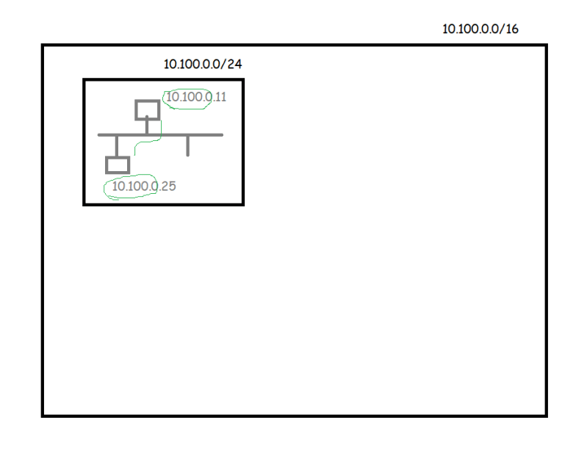
* Two devices in the different network cannot communicate directly 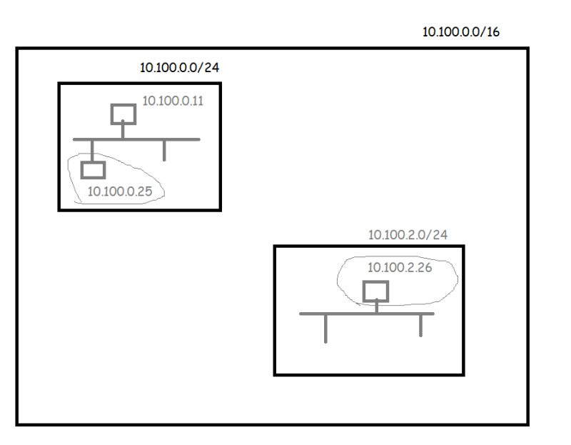
* In networking we have a device called as router which can forward packets from one network to other
* Routers will forward the packets from one network to other depending on the routes configured
* see the following image from tracing route to reach public servers 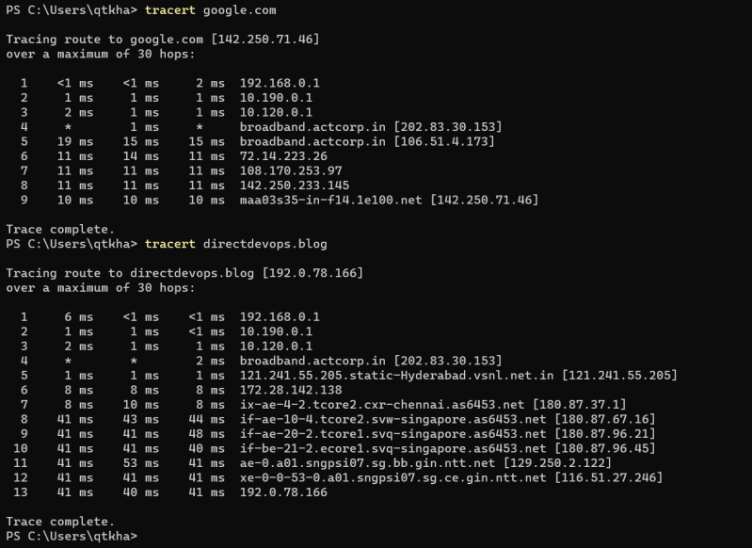
* Basic image 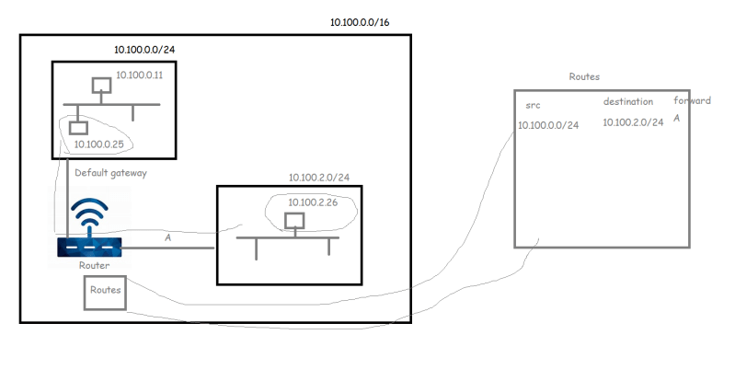

**Lets understand on Networking in AWS**

* To create networks in AWS, we need to understand
  + Regions: Geographical location where AWS has datacentres
  + Availability zones (AZ): These are the actual sites within a Region where AWS hosts the infrastructure. Two AZ’s in a region will be typically 30 – 60 kms far away from each other. There will be a dedicate optical fiber network b/w AZ’s

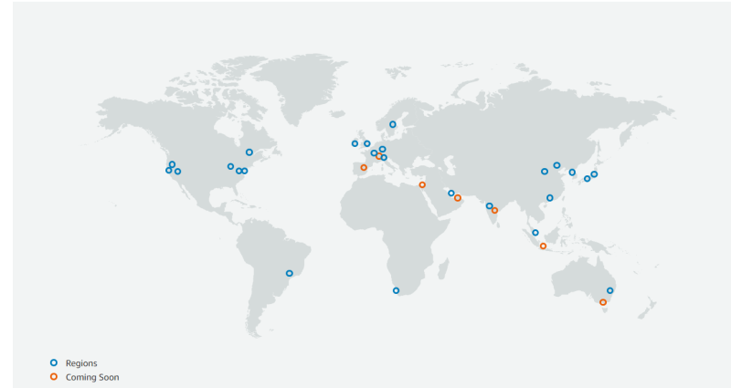

* + 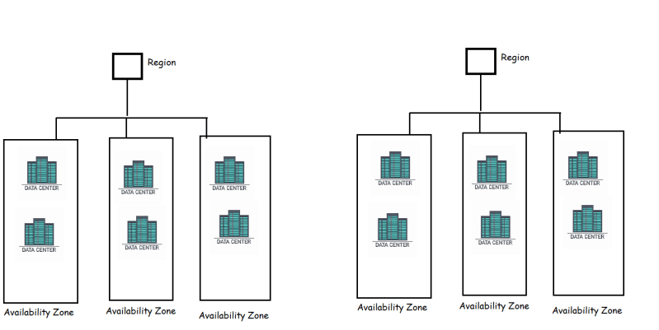
* To create a network in AWS, we use a service called as VPC (Virtual Private Cloud)
  + Network is created at a region level
  + Subnets are created at AZ level 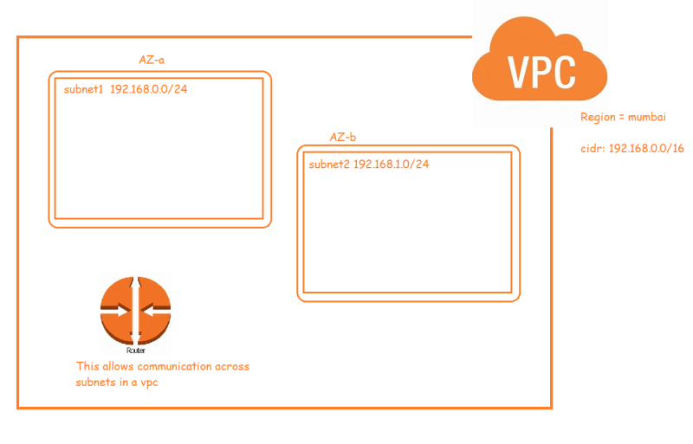
* Now lets try to create our first vpc 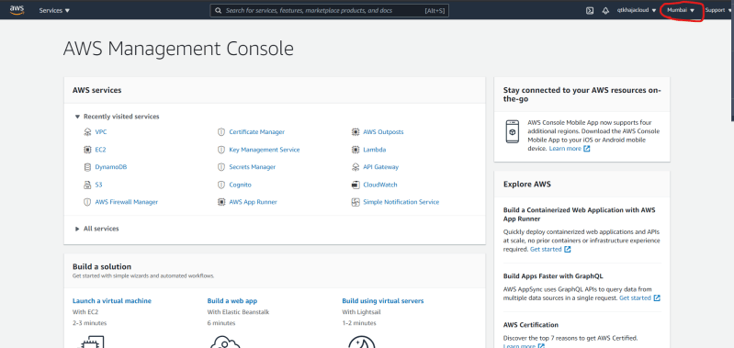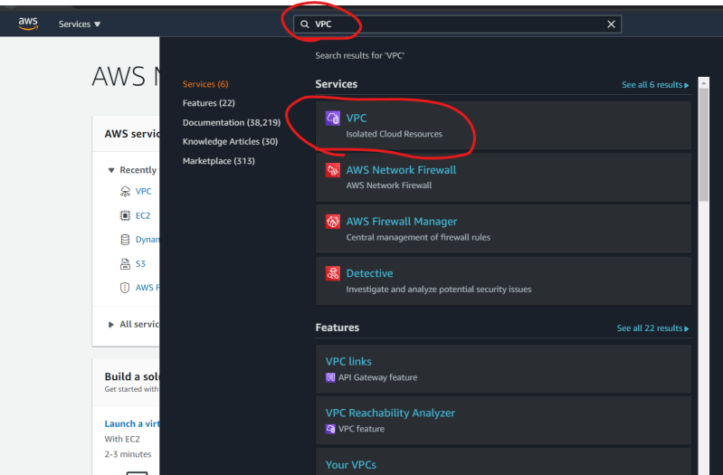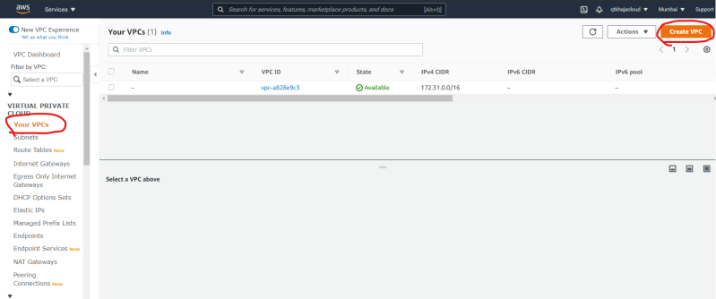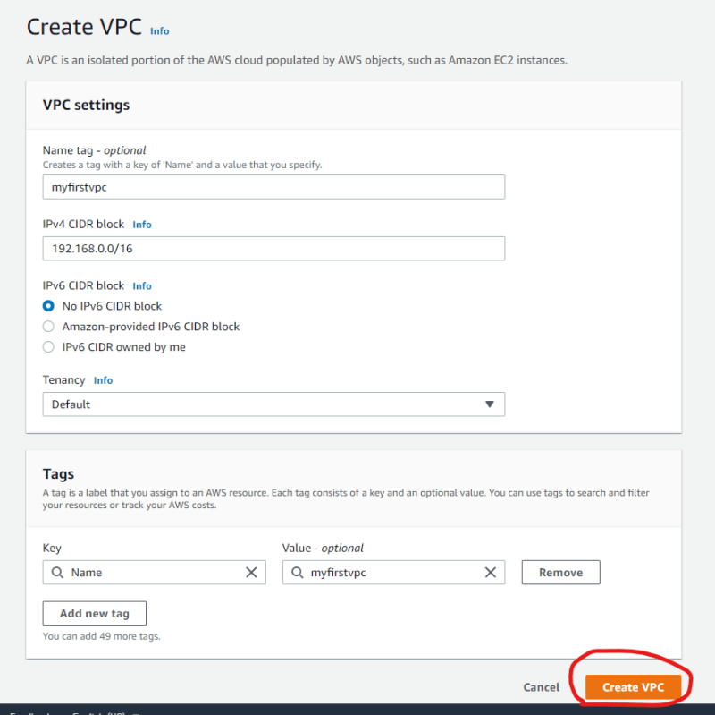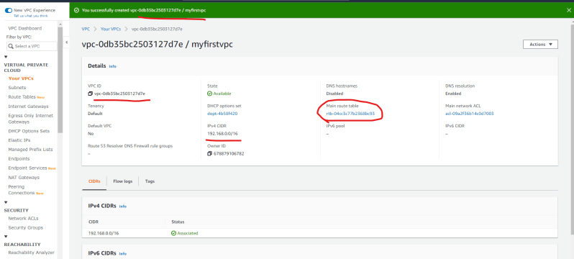
* Now lets add two subnets 